TUGAS MEMBUAT QUERY – 2

1. [SELECT](http://localhost/phpmyadmin/url.php?url=https://dev.mysql.com/doc/refman/8.0/en/select.html) * FROM data_pegawai ORDER BY tanggal_lahir DESC

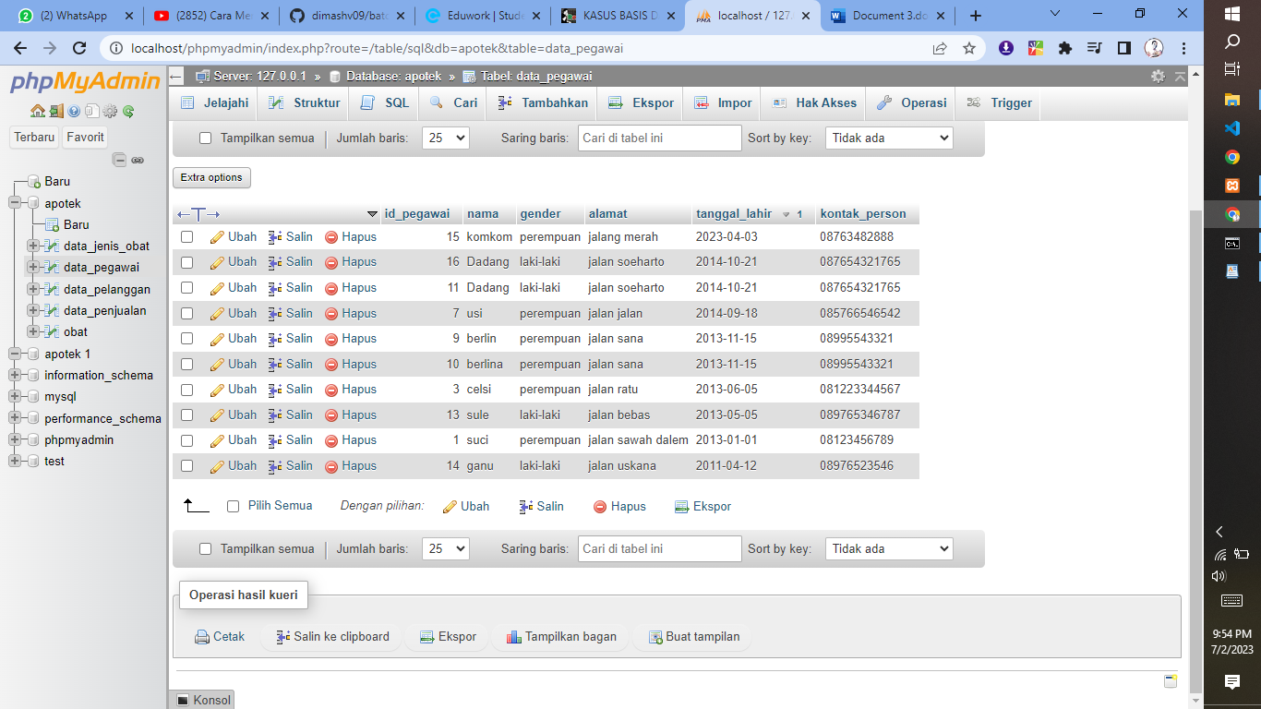

1. [SELECT](http://localhost/phpmyadmin/url.php?url=https://dev.mysql.com/doc/refman/8.0/en/select.html) * FROM data_pegawai ORDER BY tanggal_lahir ASC

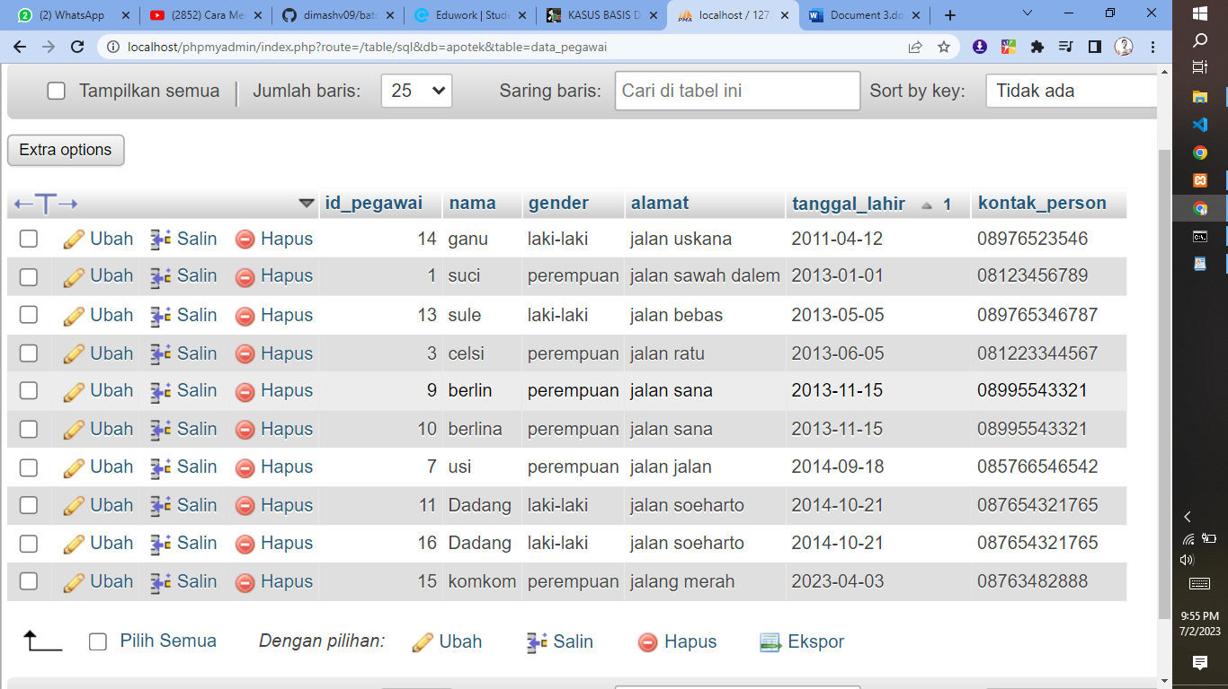

1. [SELECT](http://localhost/phpmyadmin/url.php?url=https://dev.mysql.com/doc/refman/8.0/en/select.html) * FROM data_pegawai WHERE gender [LIKE](http://localhost/phpmyadmin/url.php?url=https://dev.mysql.com/doc/refman/8.0/en/string-comparison-functions.html%23operator_like) '%PEREMPUAN%'

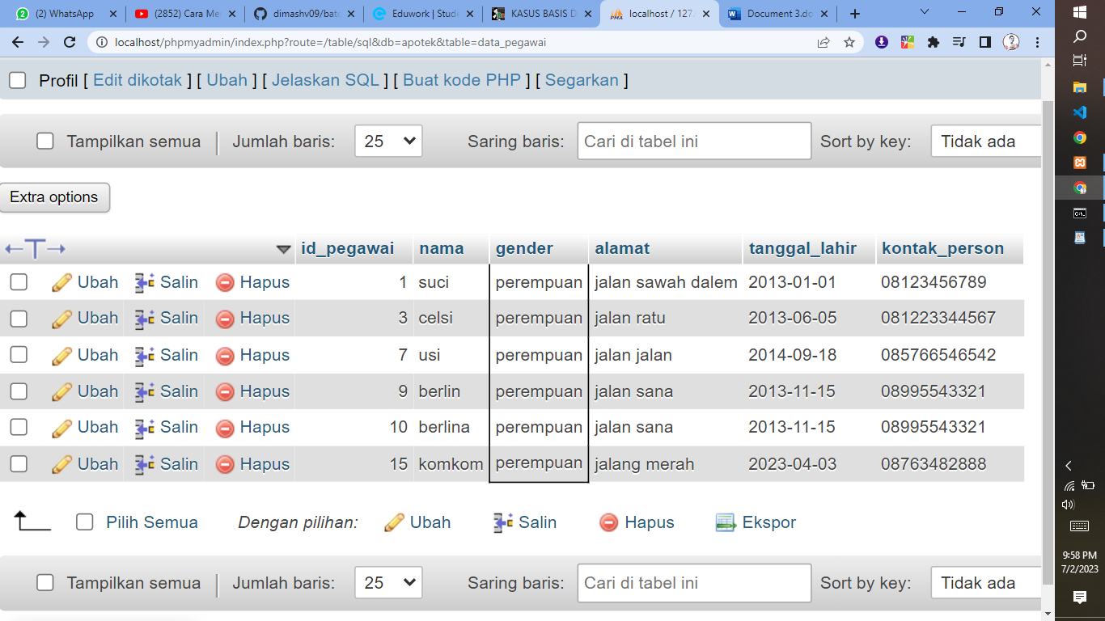

1. [SELECT](http://localhost/phpmyadmin/url.php?url=https://dev.mysql.com/doc/refman/8.0/en/select.html) * FROM data_pegawai WHERE gender [LIKE](http://localhost/phpmyadmin/url.php?url=https://dev.mysql.com/doc/refman/8.0/en/string-comparison-functions.html%23operator_like) '%LAKI-LAKI%'

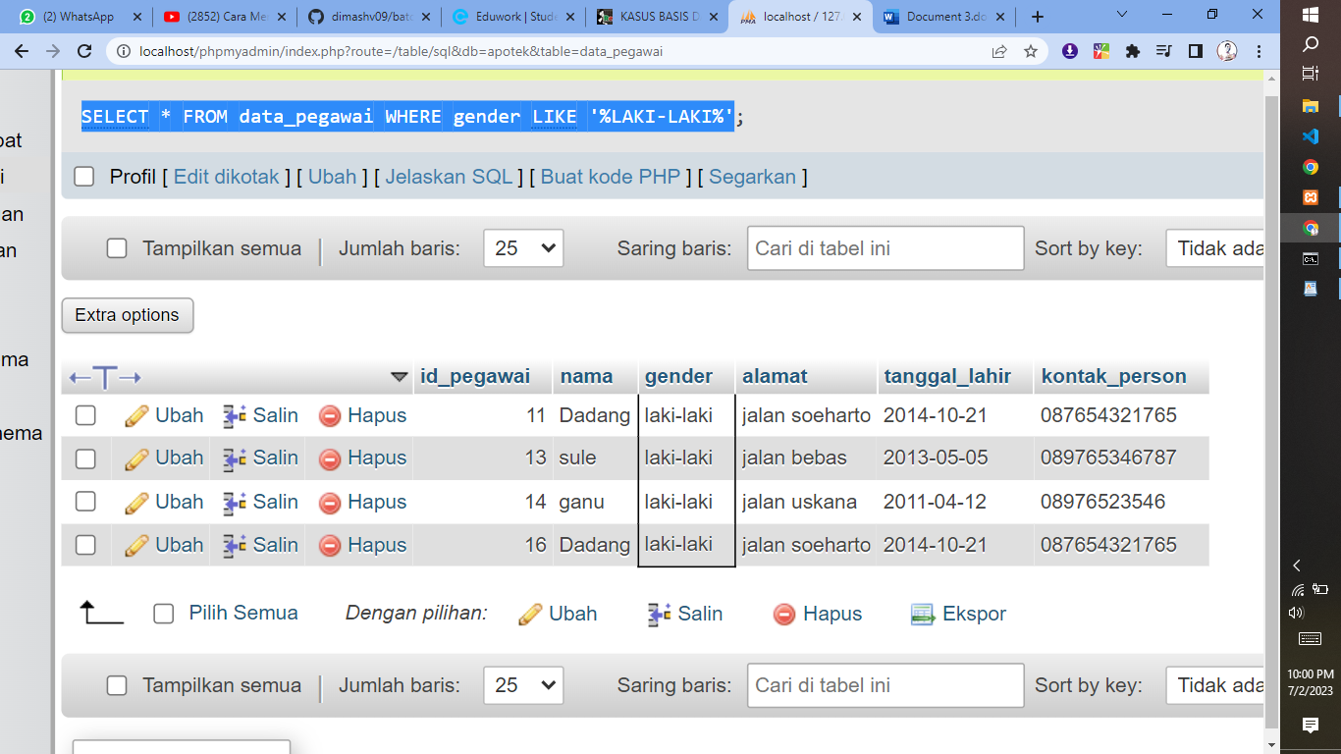

1. [SELECT](http://localhost/phpmyadmin/url.php?url=https://dev.mysql.com/doc/refman/8.0/en/select.html) kode_obat, [SUM](http://localhost/phpmyadmin/url.php?url=https://dev.mysql.com/doc/refman/8.0/en/aggregate-functions.html%23function_sum)(jumlah) as total FROM `detail_pemesanan` GROUP BY kode_obat;

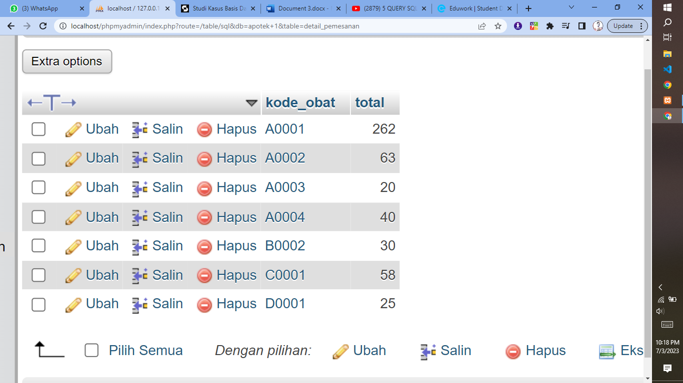

1. [SELECT](http://localhost/phpmyadmin/url.php?url=https://dev.mysql.com/doc/refman/8.0/en/select.html) kode_pesan, [SUM](http://localhost/phpmyadmin/url.php?url=https://dev.mysql.com/doc/refman/8.0/en/aggregate-functions.html%23function_sum)(jumlah) as total FROM `detail_pemesanan` GROUP BY kode_pesan;

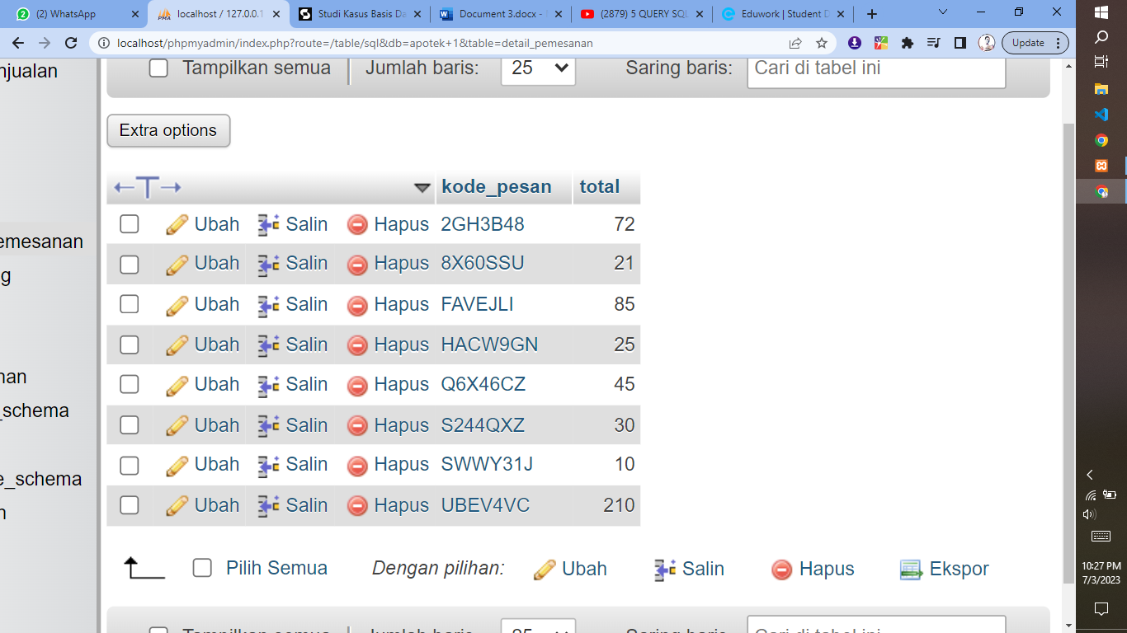

1. [SELECT](http://localhost/phpmyadmin/url.php?url=https://dev.mysql.com/doc/refman/8.0/en/select.html) id, [SUM](http://localhost/phpmyadmin/url.php?url=https://dev.mysql.com/doc/refman/8.0/en/aggregate-functions.html%23function_sum)(jumlah) as total FROM `detail_pemesanan` GROUP BY id;

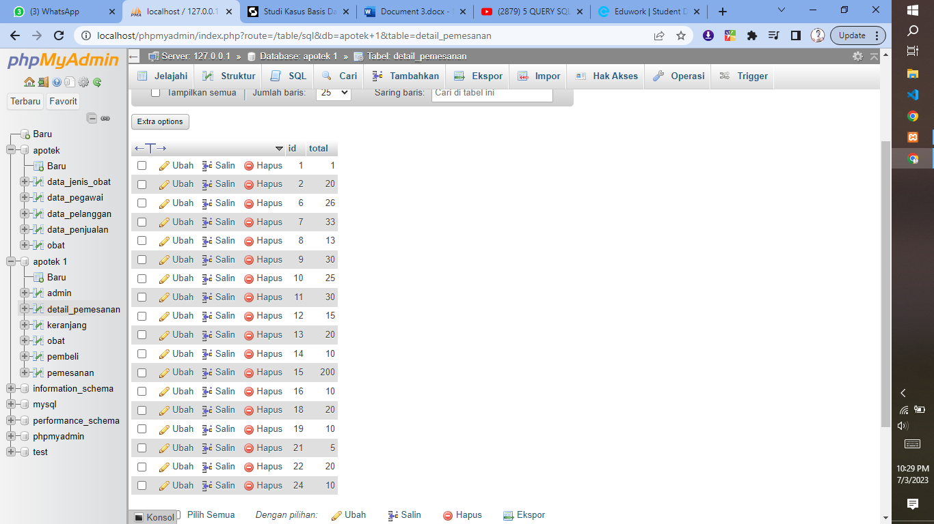

1. [SELECT](http://localhost/phpmyadmin/url.php?url=https://dev.mysql.com/doc/refman/8.0/en/select.html) tanggal, [SUM](http://localhost/phpmyadmin/url.php?url=https://dev.mysql.com/doc/refman/8.0/en/aggregate-functions.html%23function_sum)(id_pemesan) as total FROM `pemesanan` GROUP BY tanggal;

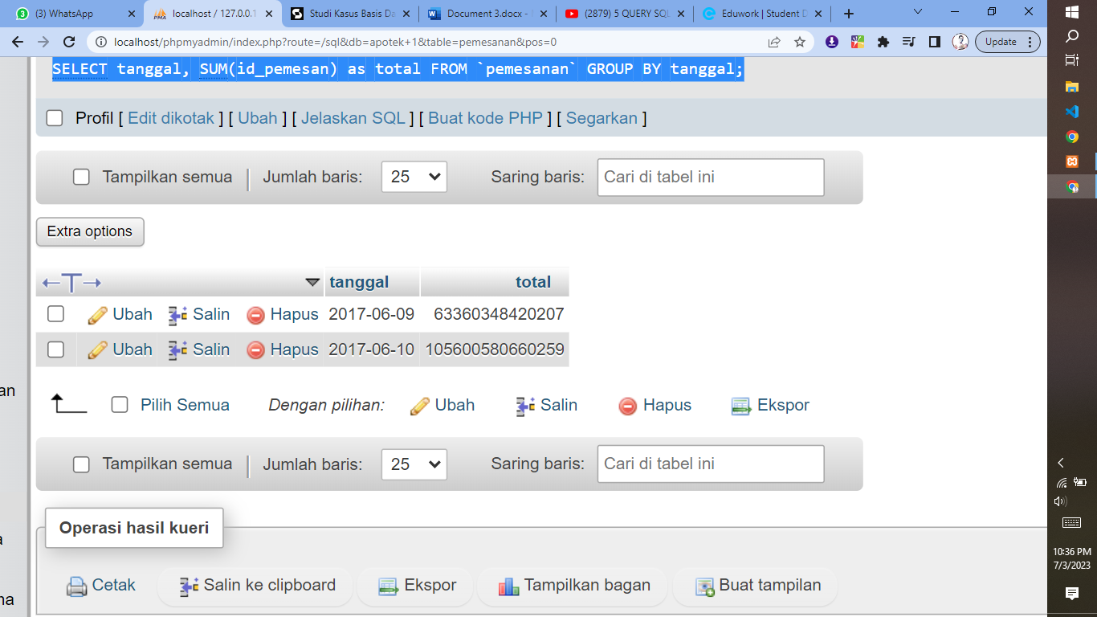

1. SELECT harga, SUM(konsumen) as total FROM `obat` WHERE harga >= 15000 GROUP BY harga ORDER BY harga DESC;

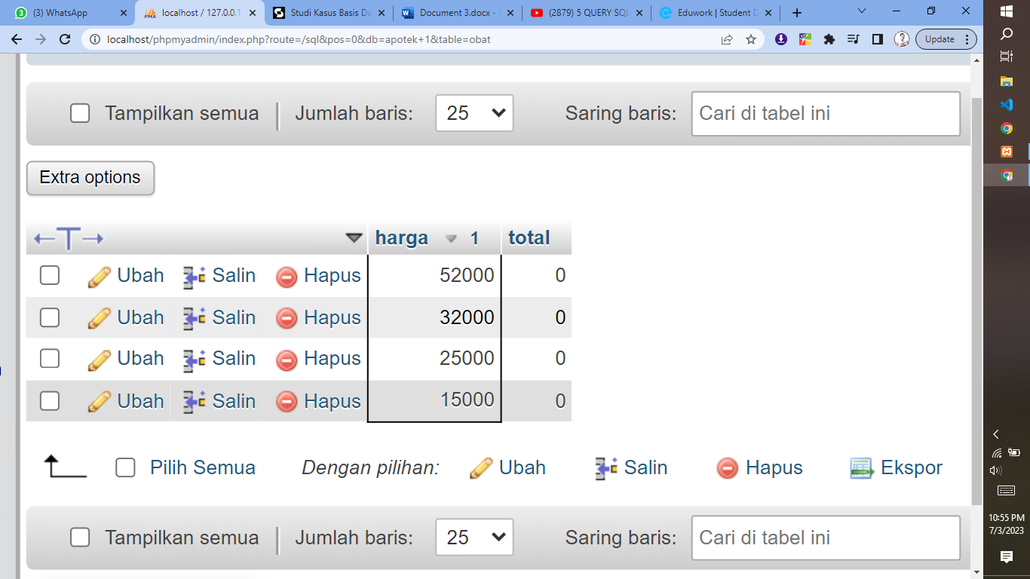

1. [SELECT](http://localhost/phpmyadmin/url.php?url=https://dev.mysql.com/doc/refman/8.0/en/select.html) harga, [SUM](http://localhost/phpmyadmin/url.php?url=https://dev.mysql.com/doc/refman/8.0/en/aggregate-functions.html%23function_sum)(konsumen) as total FROM `obat` GROUP BY harga ORDER BY harga ASC;

